

Name – Divyansh Mishra
Reg. No. – 25BAI11302
Email – divyansh.25bai11302@gmail.com
Project – Cricket Statistics Calculator

Contents
- Problem Statement
- Requirements
- Design
- Algorithm
- Flowchart
- Code and Implementation
- Resources

Problem Statement

The program should accept user input, perform the necessary calculations, handle invalid inputs, and display results clearly. The program should also be capable of handling invalid inputs such as alphabets or special characters and must notify the user with an appropriate error message without crashing. By the end of program execution, it should clearly display the calculated batting average and strike rate in a user-friendly format.

Requirements

Functional Requirements
- The system must take three inputs:
  - Total runs scored by player
  - Total balls faced by player
  - Number of times the player got out

- The system must calculate:
  - Batting Average = Total Runs / Number of times out
(Show “N/A” if outs = 0)
  - Strike Rate = (Total Runs / Balls Faced) × 100
(Show “N/A” if balls faced = 0)
- The system must display the calculated results.
- The system must validate user inputs:
  - Only numbers are allowed
  - Display an error message for invalid input
Non-Functional Requirements
- The program should be simple and user-friendly.
- It should handle errors without crashing.
- Execution must be fast (small program).

Design

Input Design
- Inputs taken as strings and then converted:
  - Runs → float
  - Balls → integer
  - Outs → integer
Output Design
- Clear labelled results:
  - Batting Average (2 decimal places)
  - Strike Rate (2 decimal places)
  - Or “N/A” when calculation is not possible
Process Design
- Validate the input using try-except.
- Perform calculations based on cricket formulas.
- Display results.

Algorithm
- Start the program.
- Display program title “Cricket Stats”.
- Ask the user to input:
  - Total runs
  - Total balls faced
  - Number of times out
- Try converting runs to float, balls and outs to integers.
- If conversion fails:
  - Display “Enter correct numbers!”
  - Stop the program.
- If outs > 0:
  - Calculate Batting Average = runs / outs
  - Else: Batting Average = “N/A”
- If balls > 0:
  - Calculate Strike Rate = (runs / balls) × 100
  - Else: Strike Rate = “N/A”
- Display results.
- End program.
Flowchart

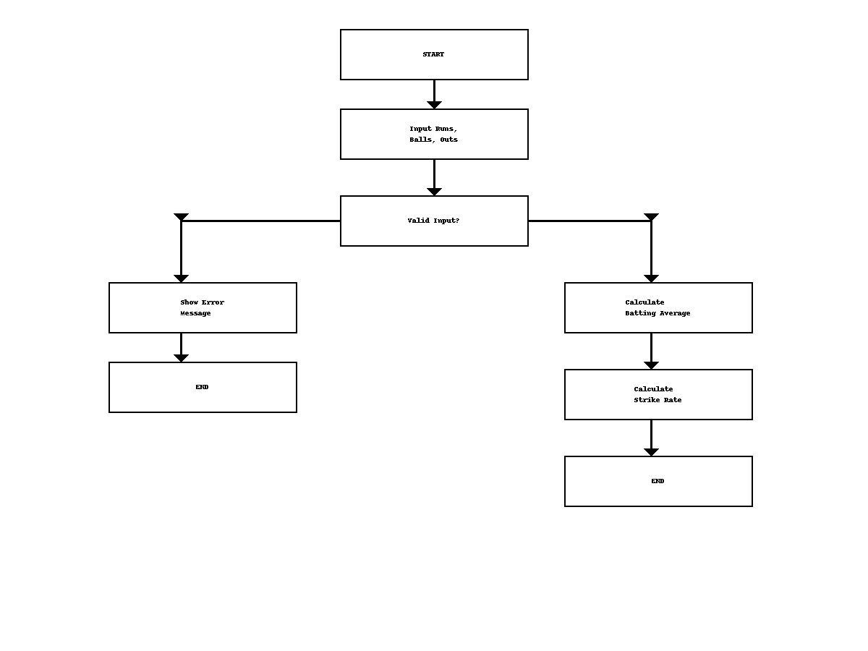

Code/Implementation
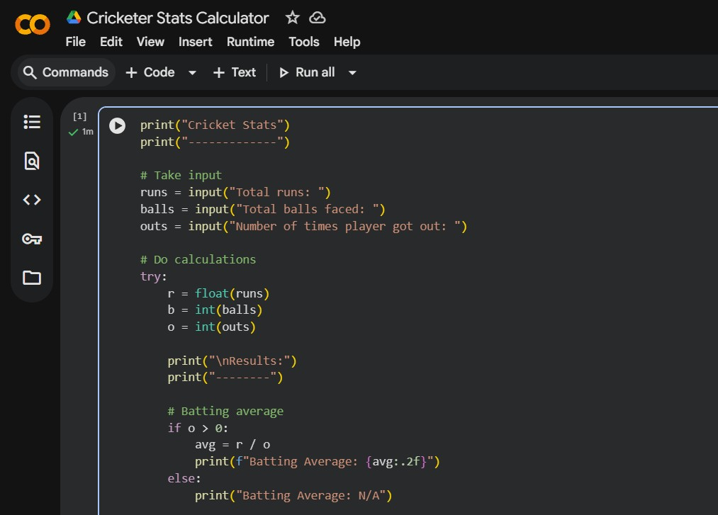
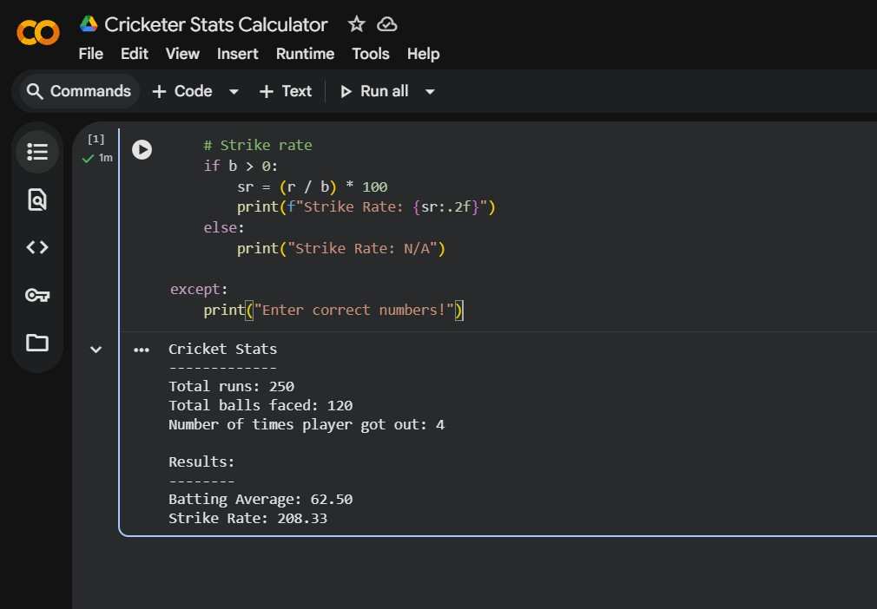

Resources

- Python Programming Language
Used to write the entire program and handle user input, loops, error handling, and function creation.

- Requests Library (Python)
This library was used to send HTTP requests.

- VS Code (Visual Studio Code)
Used as the code editor to write, edit, and run the Python program.



